**Website Topic**

I am designing a website for a fictional football club, “Hari FC”. The main target audience for this website are the fans. The website provides lots of information to the fans and make the feel closer to the club.

Information that would be included on the website is the league standings. This shows where the club currently seats in the league as well as the league position of rival teams. It also displays the number of games each club in the league has played, number of games won, number of goals scored, number of goals conceded, the goal difference and the number of points each team has earned.

The website will also display the upcoming matches of the club as well as the results within a certain time period. The website would also provide team information, such as the players in each team (both the first team as well as the youth team) and their roles.

A page on the website is also dedicated just to display some of the historical achievements of the club. The website will also include a page for stadium news such as upgrades and other information related to the stadium. Last but not least, the website will also include a registration form page that allows fans to subscribe to weekly newsletter as well as other services offered by the club.

**Proposed URL**

Proposed URL is – harifc.com

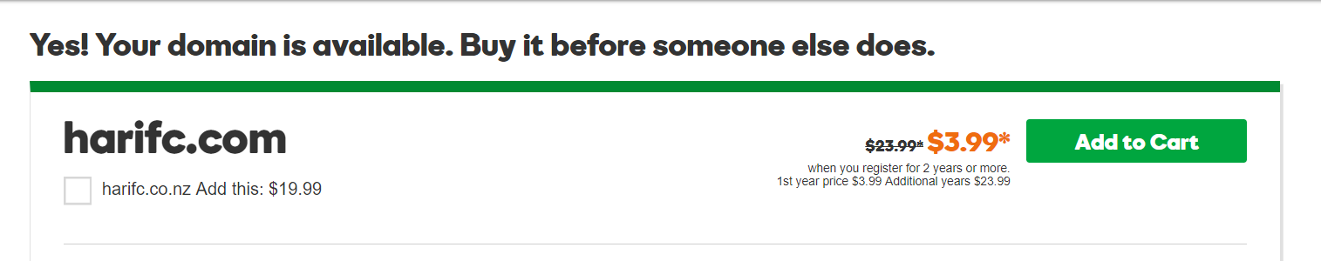

**Navigation Diagram**

Registration

(Registranion.html)

League Standings

(Standings.html)

Stadium

(Stadium.html)

Teams

(Squad.html)

History

(History.html)

Fixtures & Results

(Matches.html)

Home Page

(Index.html)

Ladies Team

(Ladies.html)

Youth Team

(Youth.html)

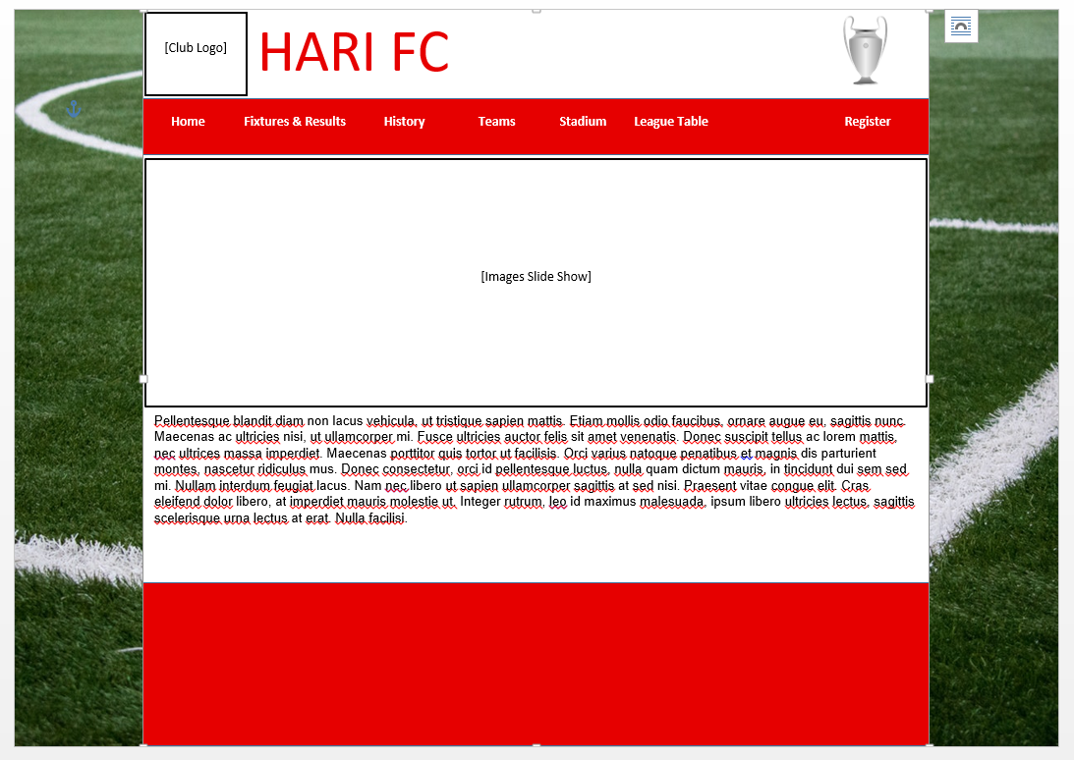**Home Page**

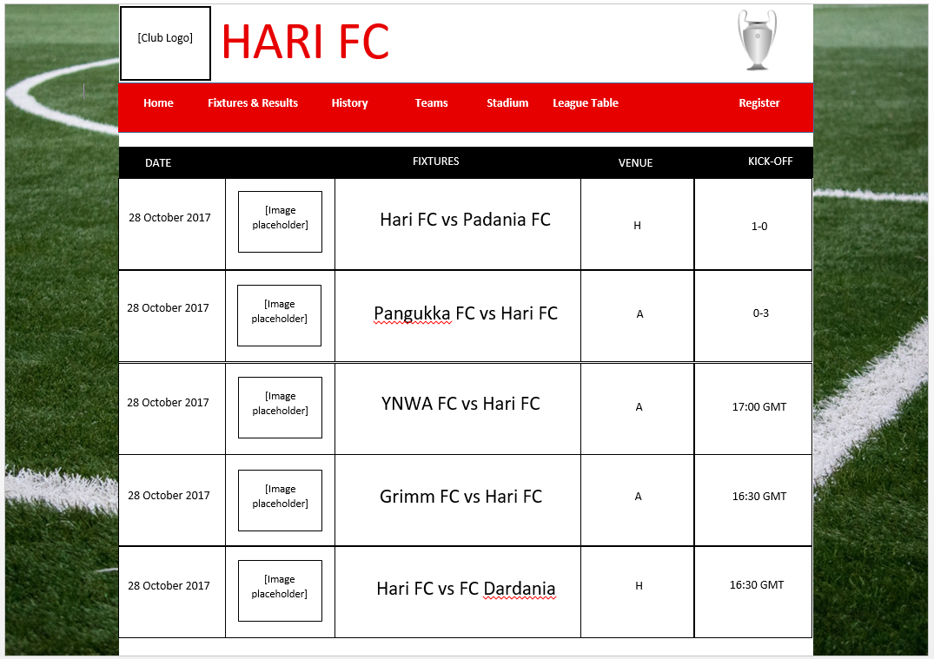**Fixture & Results**

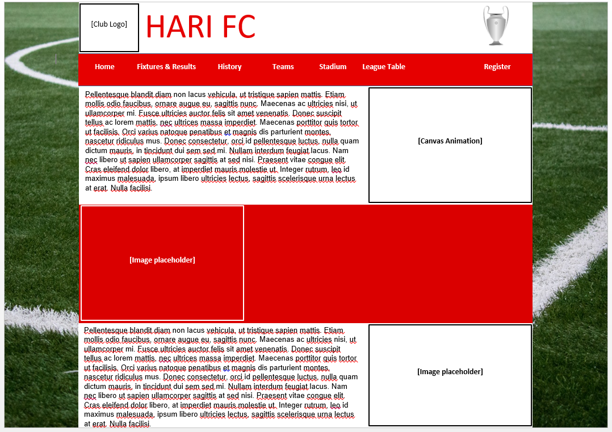**History**

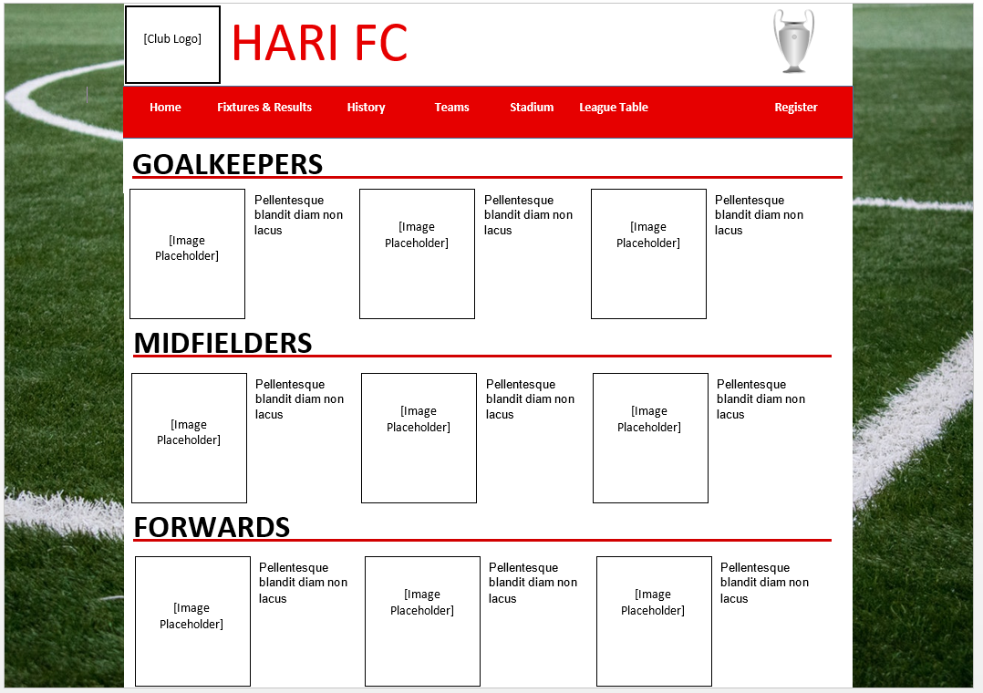**Teams**

**Stadium**

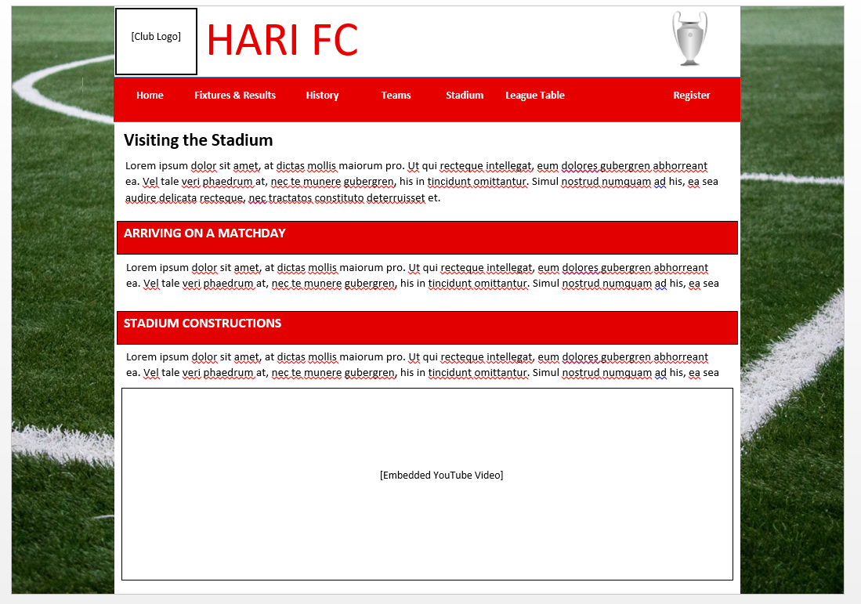

**League Table**

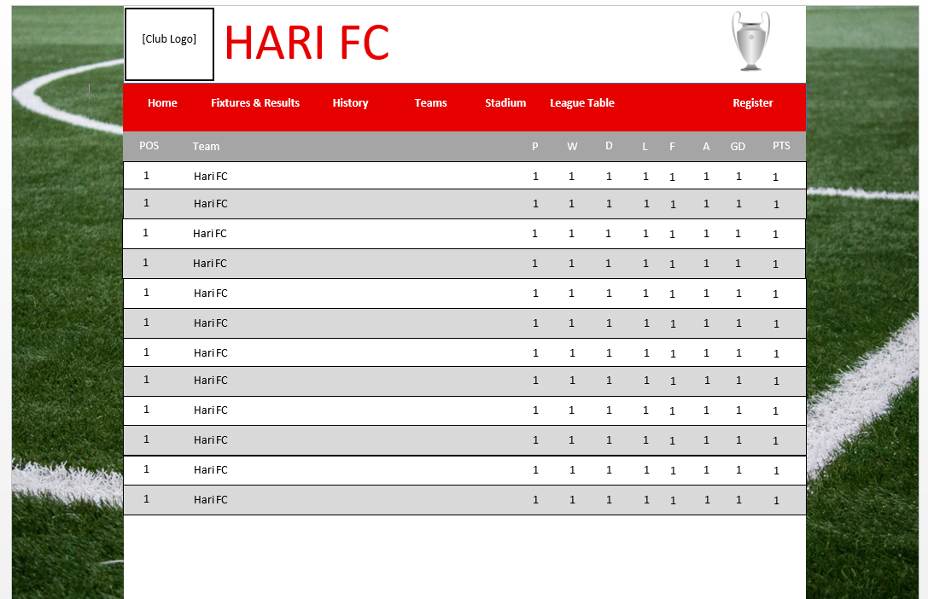

**Register**

